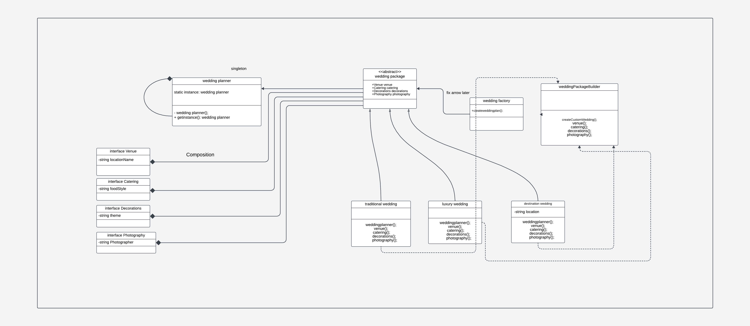
Explaination:

I use the factory pattern to be able to make different type of wedding packages
This is because every wedding package contains "Luxury Venue", "Gourmet Buffet", "Elegant Flowers", "Professional"). This is the most suitable because it allow each package to reduce code by extending from a package that contains these. Additionally if there were more packages, they can extend and create another kind of package as well. (error package example I set everything to not selected)

I used an interface because my intentions was that it is abstract meaning that It does not hold a default value when a package extends from it.

The singleton job is to provide the planner. And the reason it is the best pattern for this is that we do not want to create multiple different ways to display the same information as it is tedius and could lead to inconsistancy. instead, every package can make an instance of it to display its information.

The builder pattern allow customization for the packages. This is perfect because hypothetically, a client want to change a venue type that is not originally offered, that is possible with minimal changes. Without the builder they would need to either create a whole new package.

